**THOUGHTSPOT vs POWER BI: A Detailed Comparison**

**Introduction:**  
  
 In today's data-driven world, businesses rely on powerful analytics platforms to make informed decisions. A couple of well-known competitors in this field include ThoughtSpot and Power BI. For data analysis, reporting, and visualization, both programs provide a wealth of options. All users, regardless of skill level, can easily operate the self-service BI platform ThoughtSpot. Since ThoughtSpot uses Natural Language Processing (NLP), users can ask inquiries in plain English about their data. More technical know-how is needed to use Power BI, a more conventional BI tool. For data modeling, data visualization, and report writing, Power BI provides a plethora of functions. Enterprise-grade capabilities like data governance and security are also available with Power BI. We will examine a number of features of both platforms in this thorough comparison to assist you in choosing the one that best suits your needs.

**User Interface and User Experience:**

**ThoughtSpot:** Known for its intuitive search-driven analytics, ThoughtSpot delivers an identical search interface to Google, allowing users to ask questions and instantly receive visualizations. Its user interface is intended to be accessible to a broad spectrum of users making it simple to use.

**Power BI:** Being a Microsoft product, Power BI provides customers who are already familiar with Microsoft's ecosystem with a distinctive UI. The creation of reports and dashboards is comparatively simple for users due to its drag-and-drop capability and intuitive design.

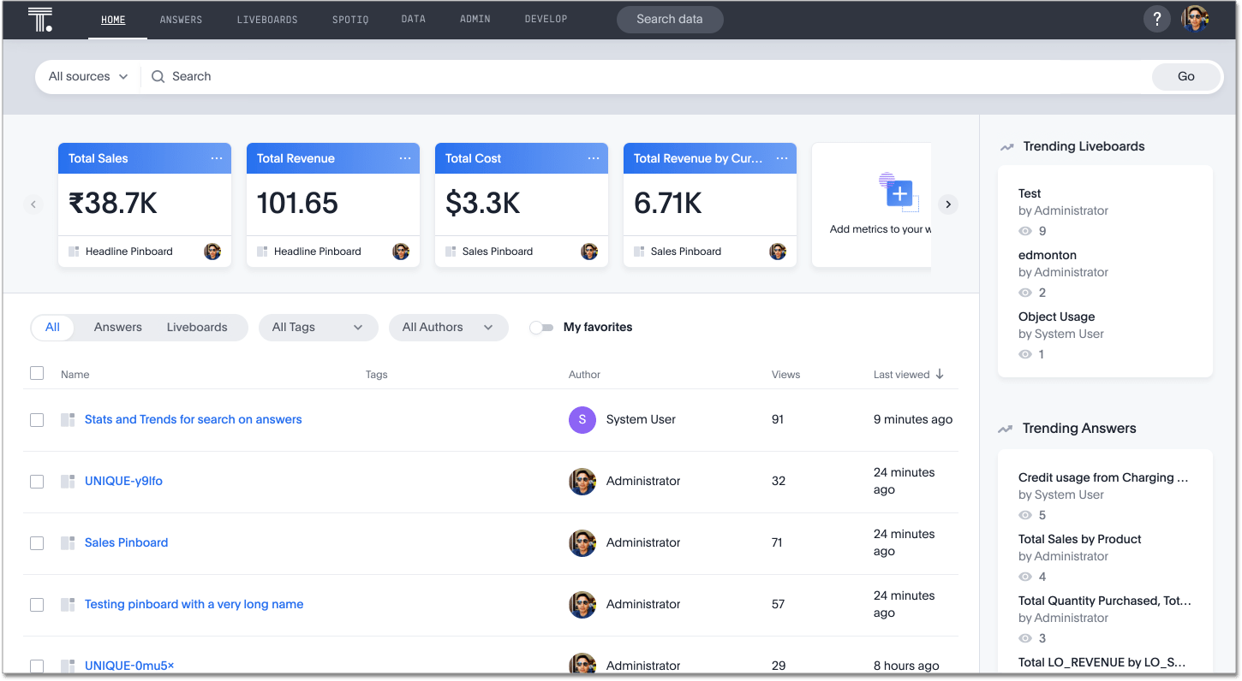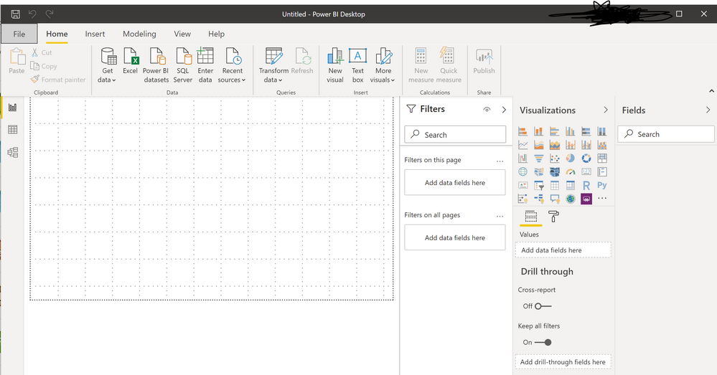

**Data Connectivity and Integration:**

**ThoughtSpot:** Thoughtspot provides an extensive range of connectors to commonly utilised data sources, including as databases, cloud computing platforms, and data warehouses.Though it offers native connectors for widely used data sources, less widely used or older data platforms might require additional integration work.

**Power BI:** Power BI is compatible with an extensive variety of data sources through a vast number of connectors. It also supports a wide range of third-party integrations and connects easily with other Microsoft services.

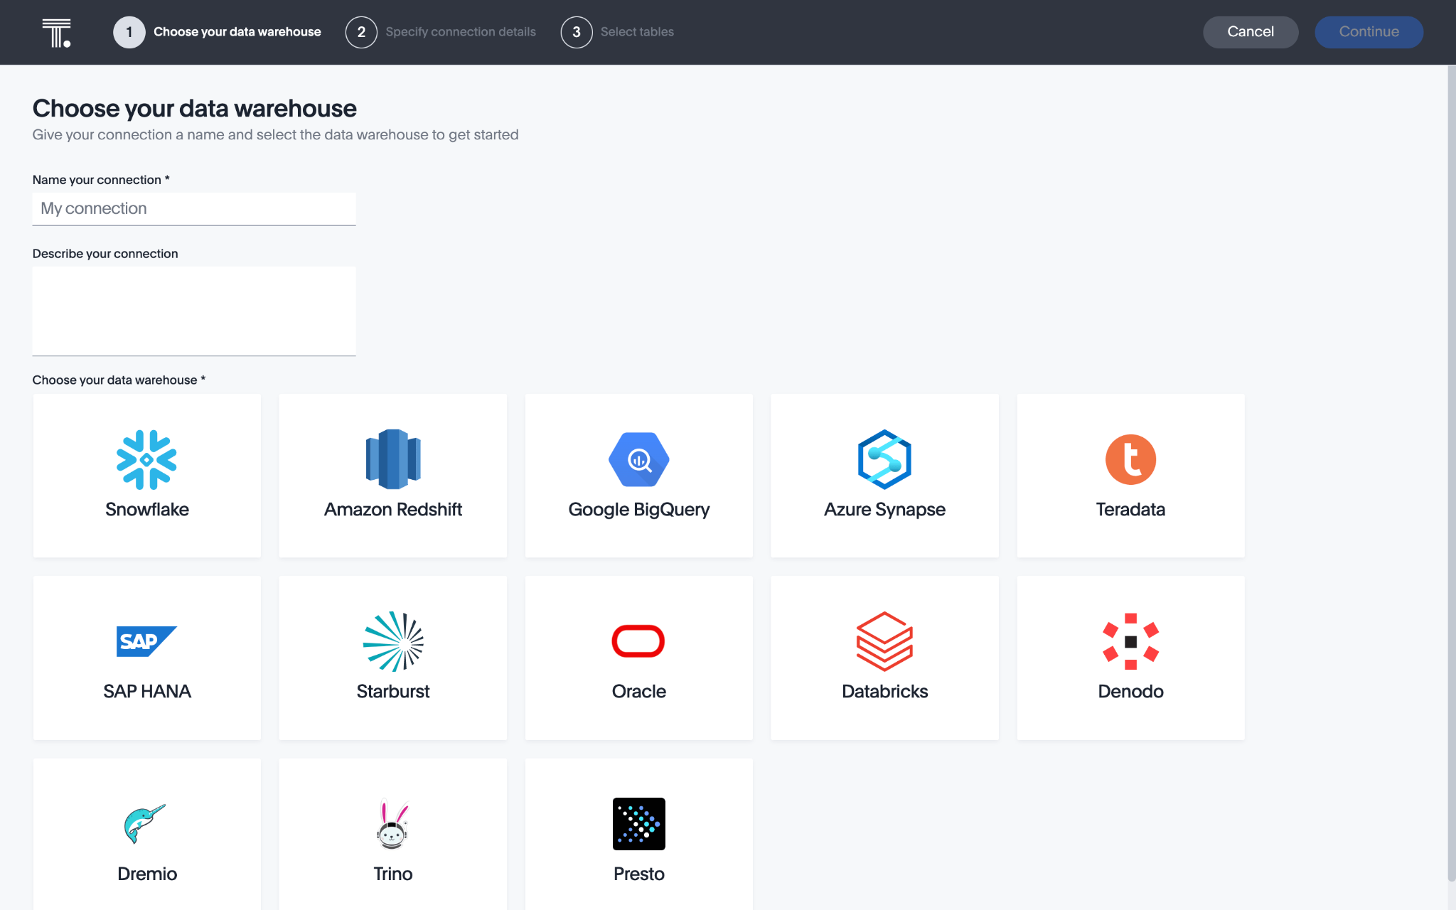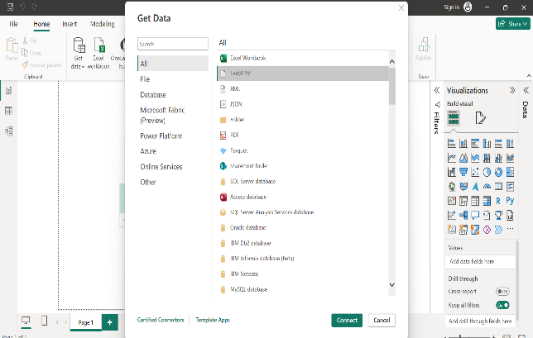

**Data Preparation and Modeling:**

**ThoughtSpot:** It is mostly focused on data discovery and visualization, but it also has some data preparation features. It could be necessary to preprocess data outside of the platform for complex data modeling.ThoughtSpot simplifies modeling while emphasising topics that are ideal for business use. It uses AI to automatically generate schema from ingested data.

**Power BI:** Power BI excels in complex data modeling, offering strong features for utilising Power Query and Data Analysis Expressions (DAX) within the platform to transform and shape data. Table associations and custom calculations can be defined by users.

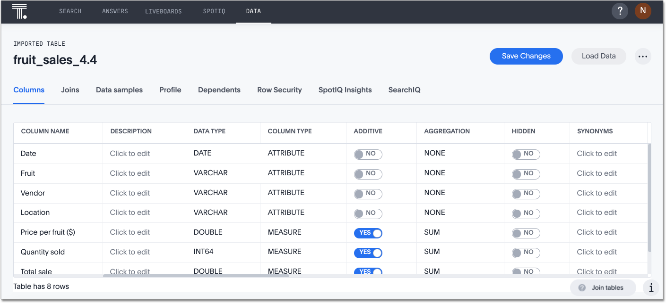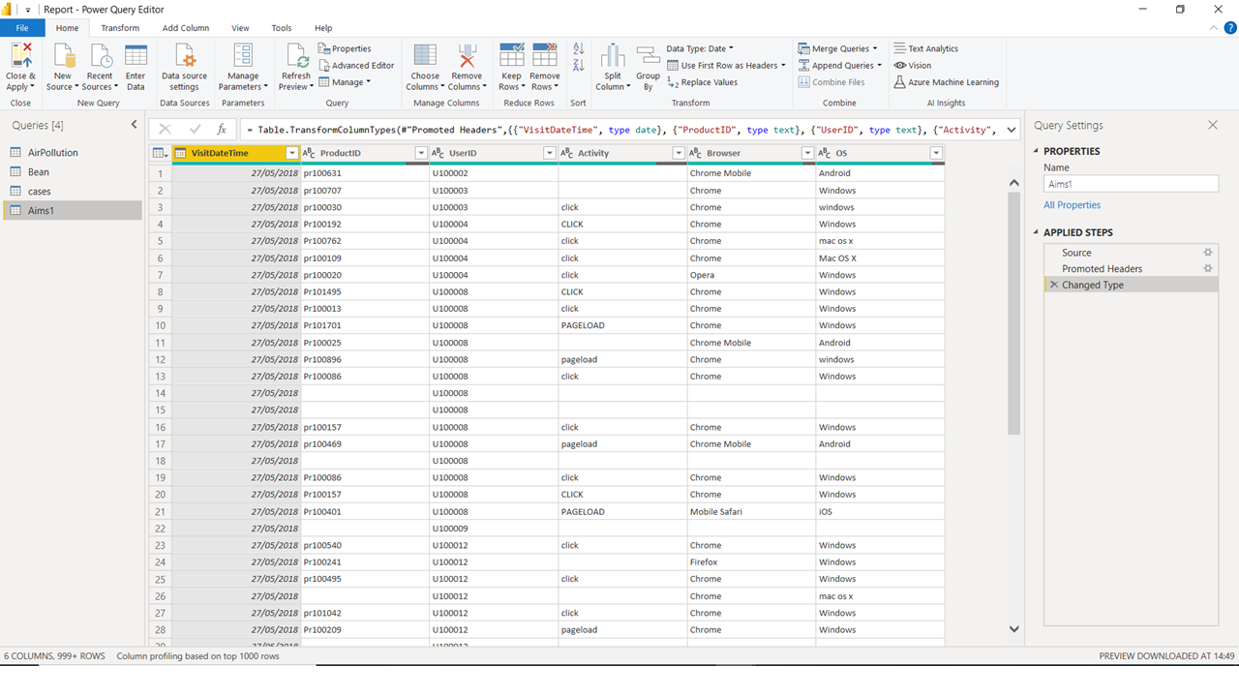

**Data Visualization and Reporting:**

**ThoughtSpot:** This tool is excellent at promptly displaying data based on natural language queries. It provides a variety of chart styles and dashboard customization options. When it comes to intricate adjustments, it might be limited.

**Power BI:** With a large library of customizations and visualizations, Power BI is known for its robust data visualization capabilities. Users are able to design drill-through and drill-down interactive reports and dashboards.

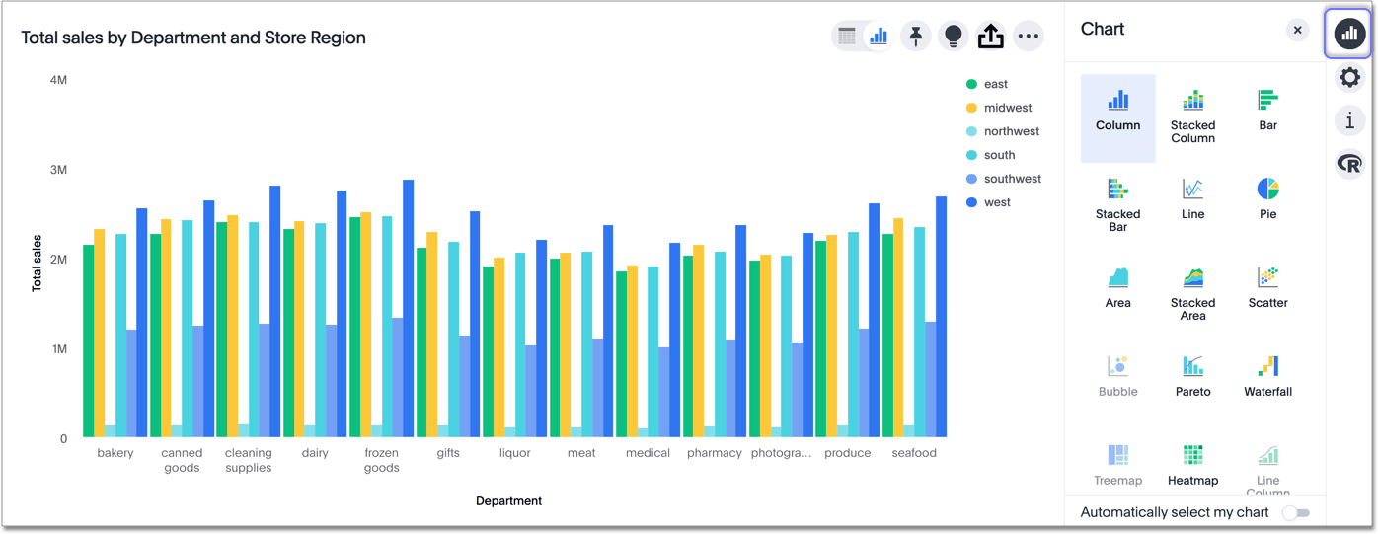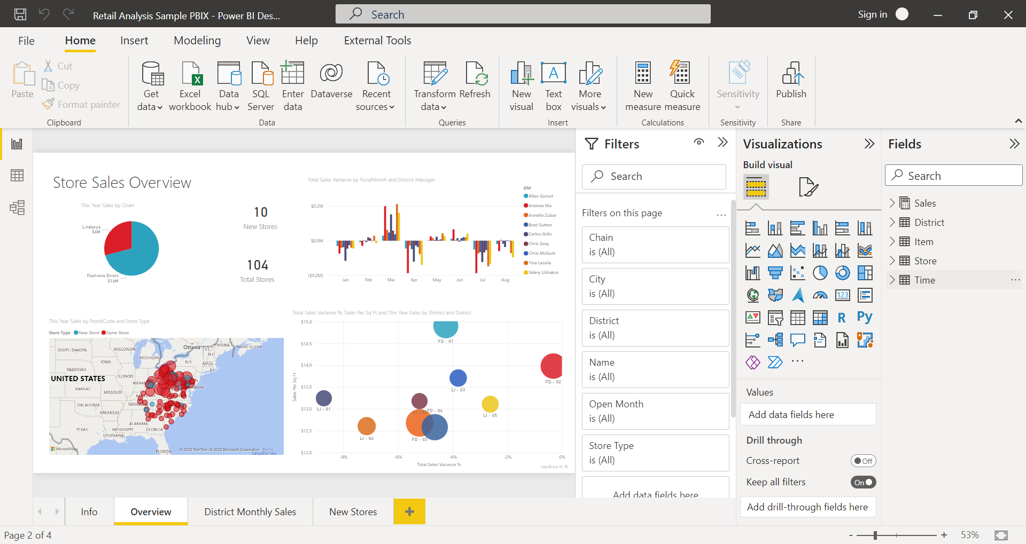

**Security and Governance:**

**ThoughtSpot:** It offers strong security measures together with data governance and role-based access management. It also smoothly connects with enterprise authentication systems and provides single sign-on (SSO).

**Power BI**: Role-based access control, data encryption, and Azure Active Directory integration are just a few of the robust security capabilities that Power BI provides. Additionally, it offers governance features at the enterprise level.

**Conclusion:**

Your unique business requirements will ultimately determine whether ThoughtSpot or Power BI is best for you. ThoughtSpot is an excellent option for businesses focusing on intuitive data discovery because of its search-driven analytics and user-friendly design. However, Power BI is a strong option for businesses looking for a more comprehensive analytics platform because of its extensive feature set, which excels in data modeling, integration, and advanced visualization. Consider your options carefully, taking into account your budget, data sources, and unique needs. Think about running a trial or proof-of-concept period to evaluate how well each platform fits your objectives.